**RAJALAKSHMI ENGINEERING COLLEGE**

**RAJALAKSHMI NAGAR, THANDALAM – 602 105**



|  |
| --- |
| **CS23A34**  **USER INTERFACE AND DESIGN LAB** |
| **Laboratory Observation NoteBook** |

**Name :** Sanjay kumar.K

# Year/Branch/Section : II/CSE/C

# Register No. : 230701289 Semester : IV Academic Year: 2024-25

**Ex. No. : 7 Date : 05.04.2025**

**Register No. : 230701289 Name : Sanjay Kumar.K**

**Develop low-fidelity paper prototypes for a banking app and convert them into digital wireframes using Pencil Project**

**AIM:**

The aim is to develop low-fidelity paper prototypes for a banking app and convert them into digital wireframes with Pencil Project.

**PROCEDURE:**

Tool Link: https://pencil.evolus.vn/

**Step 1: Create Low-Fidelity Paper Prototypes**

1. Define the Purpose and Features: ○ Identify the core features of the banking app (e.g., login, account balance,transfers, bill payments).
2. Sketch Basic Layouts:
   1. Use plain paper and pencils to sketch basic screens.

○ Focus on primary elements like buttons, menus, and forms.

1. Iterate and Refine:
   1. Get feedback from users or stakeholders. ○ Iterate on your sketches to improve clarity and functionality.

**Step 2: Convert Paper Prototypes to Digital Wireframes Using Pencil Project**

1. Install Pencil Project: ○ Download and install Pencil Project from the official website.
2. Create a New Document:
   1. Open Pencil Project and create a new document.
3. Add Screens: ○ Click on the "Add Page" button to create different screens (e.g., Login,Dashboard, Transfer).
4. Use Stencils and Shapes:
   1. Use the built-in stencils and shapes to create UI elements. ○ Drag and drop elements like buttons, text fields, and icons onto your canvas.
5. Organize and Align: ○ Arrange and align the elements to match your paper prototype.
   1. Ensure that the design is user-friendly and intuitive.
6. Link Screens:
   1. Use connectors to link different screens together. ○ Create navigation flows to show how users will interact with the app.
7. Add Annotations:
   1. Include annotations to explain the functionality of different elements.
8. Export Your Wireframes: ○ Once satisfied with your digital wireframes, export them in your preferred format (e.g., PNG, PDF).

**OUTPUT:**

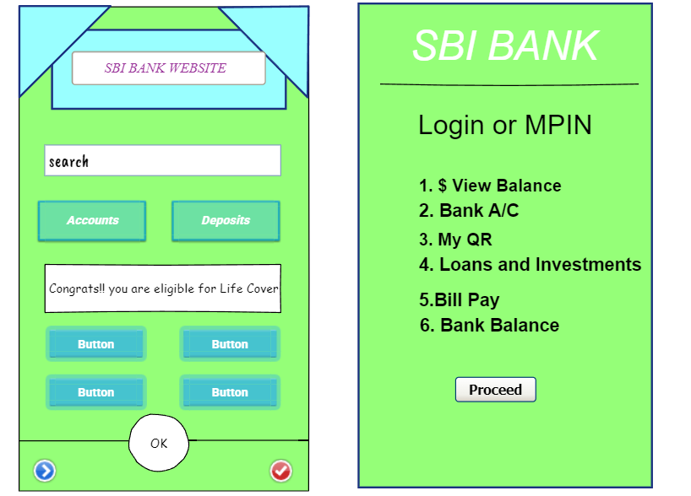

**RESULT:**

Hence low-fidelity paper prototypes for a banking app and convert them into digital wireframes with Pencil Project have been successfully executed.